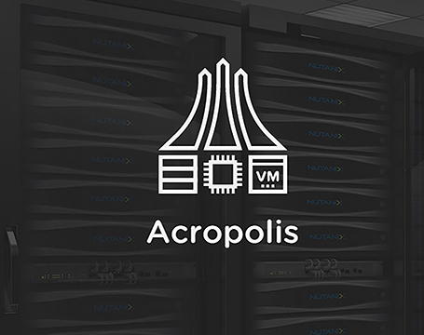

**Workshop Acropolis Hyper Visor**

For supporting NPP understanding – based on the Nutanix AHV version

# Acropolis Hyper Visor Workshop

## NPP supporting hands-on document

This demo guide is showing Acropolis Hyper Visor (AHV).

Login to the cluster by its IP Address. Use the table below.

|  |  |  |  |  |  |
| --- | --- | --- | --- | --- | --- |
| **Clustername** | **IP Address CVM** | **IP Address Hyper-Visor** | **VM Name** | **Container** | **Studentname** |
| Training12 | 10.30.3.45 | 10.30.2.45 | ub-dsk-std1 | vms-std1 | std1 |
| Training12 | 10.30.3.46 | 10.30.2.46 | ub-dsk-std2 | vms-std2 | std2 |
| Training12 | 10.30.3.47 | 10.30.2.47 | ub-dsk-std2 | vms-std3 | std3 |

Username to be used is **admin** and the password is **nutanix/4u** .

Then the HOME View should appear.

The home screen should now mention the right name of the cluster. The below screen is example for the ce1 cluster.

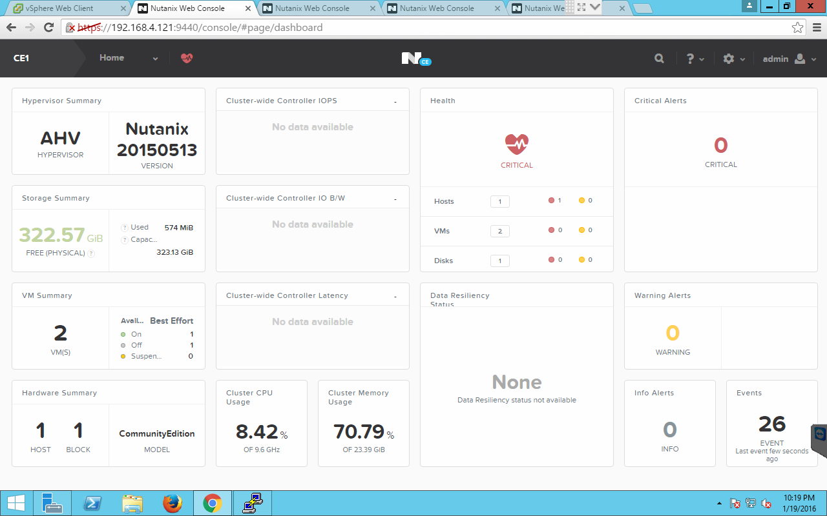

# Create Containers

As a Storage Pool has been created containers can be created. In the overview screen like below, click on **+ Container** to create a container.

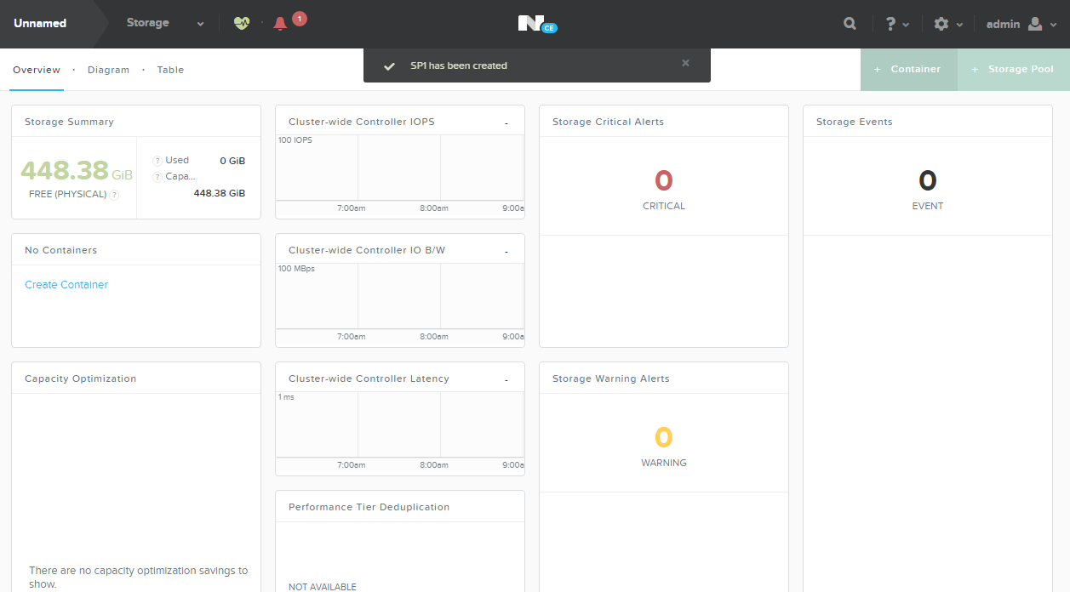

Name the container according to the earlier mentioned table in the naming convention *vms-<studentname>*. Below is an example screenshot of the studentname ce1

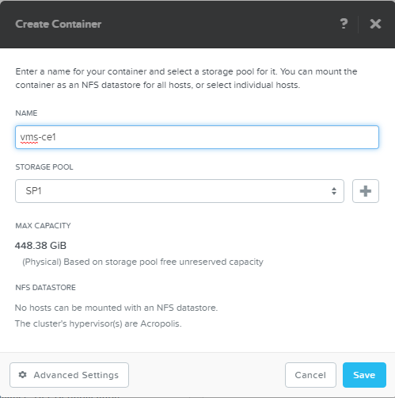

Click on the **Advanced Settings** button to see other parameters that can be set on a per container bases. Just have a look at all the options you can tick.

**REMARK: Keep the settings to default as the demo is running CE with limited resources during this workshop.**

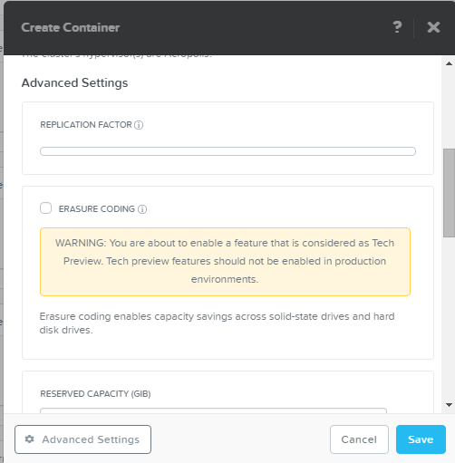

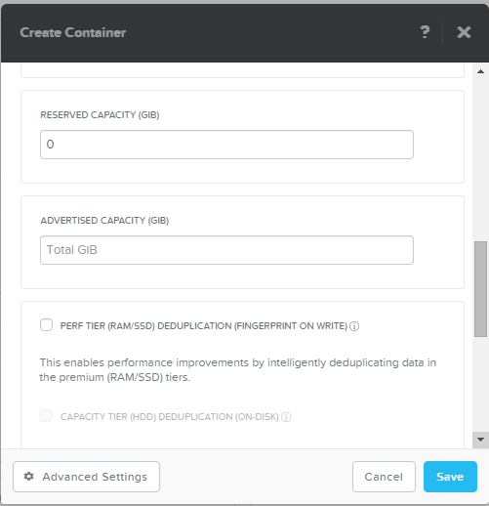

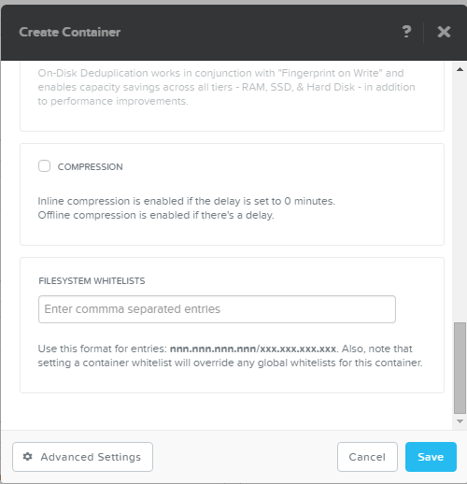

**THIS CONCLUDES STORAGE RELATED SECTION OF THIS DOCUMENT**

# Creating a Virtual Network

Change the View to VM and click **“Network Config”** on the right side of the screen. We need networking, so we need to create virtual networks first.

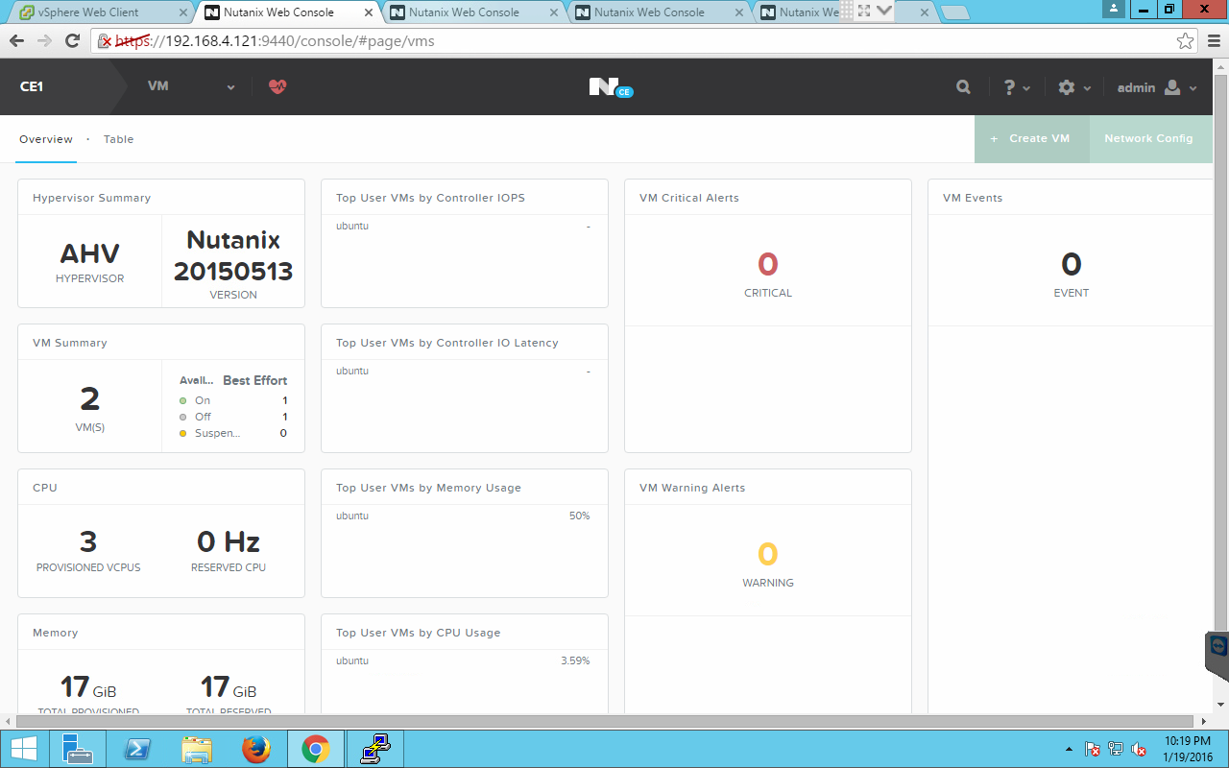

In the screen below hit the **+ Create Network** button to create a new virtual network.

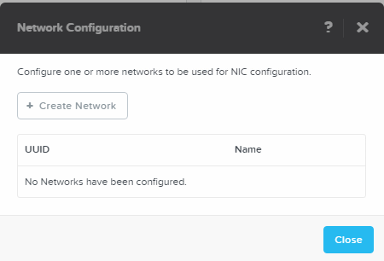

Fill the needed fields (use the below value as an example):

**Name: vlan0**

**VLAN ID: 0**

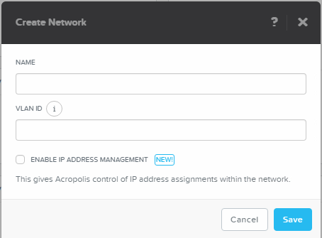

Check the **ENABLE IP ADDRESS MANAGEMENT** checkbox to see what else can be configured in the virtual network. Use again as an example the values in the screenshot

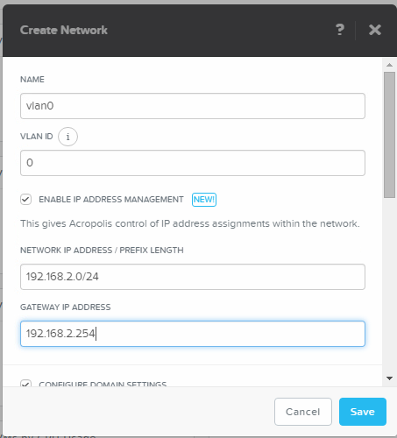

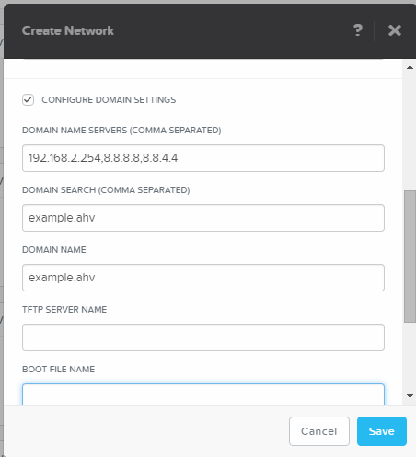

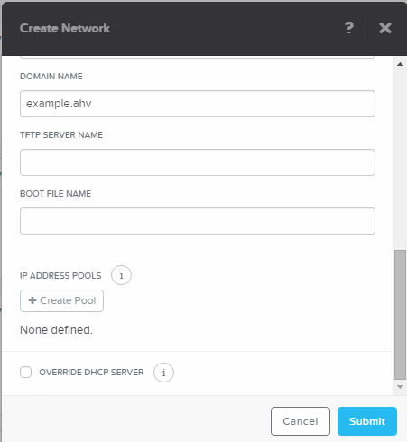

To create a DHCP-Pool in the virtual network, click the **+ Create Pool** button and use the below values again as an example

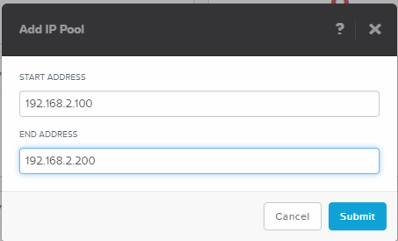

When done, click the Submit button

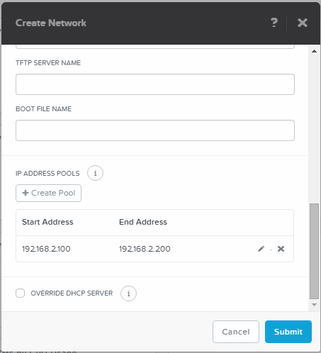

The screen should now look like the above screenshot. Now click the Submit again to get the virtual network created in the AHV environment.

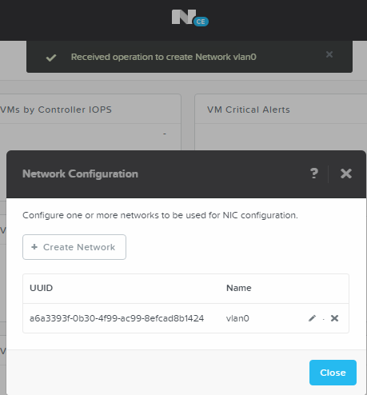

From the top a screen should drop down to tell that the network has been created, and the **Network Configuration** screen should show the just created network with its UUID and name. If you want to change anything just click the Pencil Icon right to the name of the virtual network. Repeat as many as needed.

# Creating a VM in AHV.

Back in the VM View, Click the **+ Create VM** button on the right side of the screen.



The below screen will pop up. Use the values in the screenshot for your VM you going to create. For the name please use the following namingconvention:

*ub-dsk-<studentname >* example for studentname ce1 **ub-dsk-ce1**. The screenshot below is an example for a UB server installation

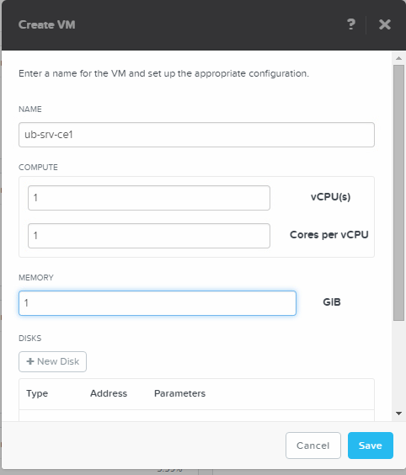

Define a disk so we can write data to the VM. Hot the **+ New Disk** button to create as many disk one at a time as we need for the VM.

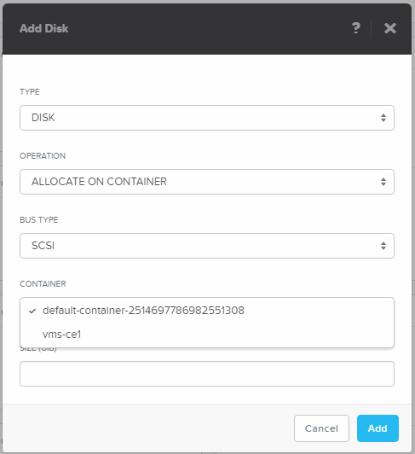

**Change the container to the one we’ve created earlier**. If you haven’t created it, Cancel this action and go to the Storage View and create a container quickly. Name it vms-<studentname>. As an example on student­­­, called CE1, you create a container called vms-**ce1**, and return to the VM creation and disk creation screen like above.

Create a 10GB disk in the right container. Create a 10GB disk

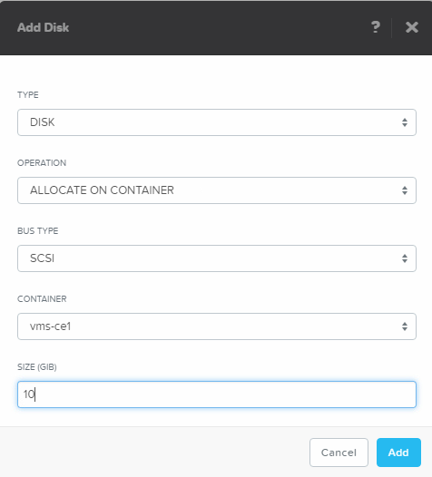

Now let’s change the CD to something useful instead of an empty one. Click the pencil button just right to the CDROM

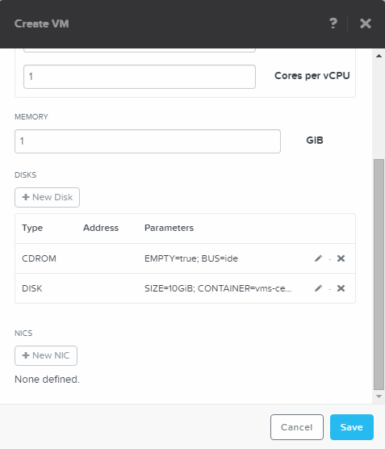

A new screen will appear

Change the OPERATION into **CLONE FROM IMAGE SERVICE**

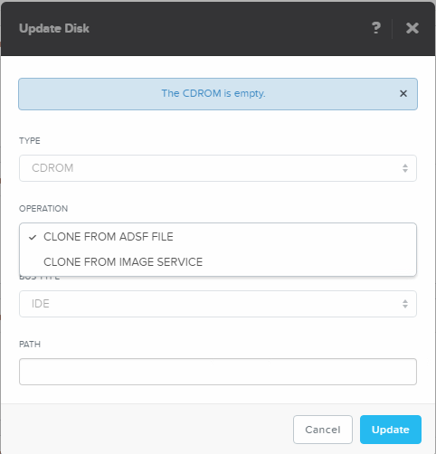

Select the Ubuntu desktop image that is available in the cluster

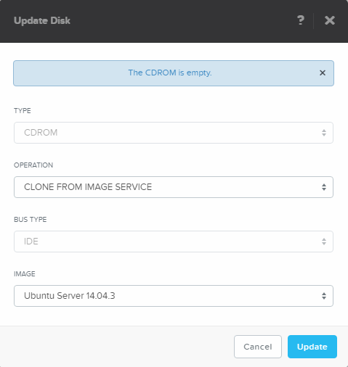

Click the **Update** button to return to the VM definition.

If you want to change uploaded ISO images after creation of the VM, click on the gear-icon in the top right hand corner and select **Image Configuration**.

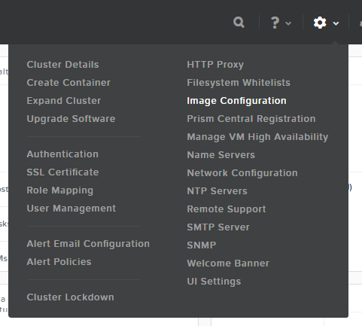

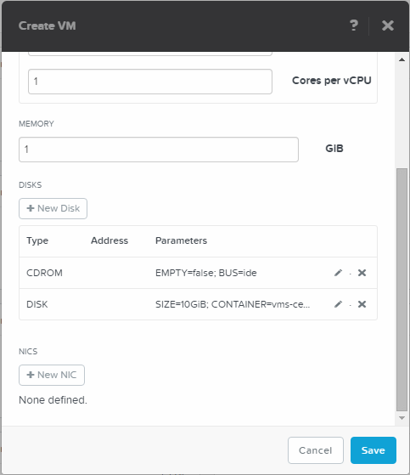

As this is an example we are going to use the earlier created virtual network. Click  **+ New NIC** to add a network connection to one of the created virtual networks

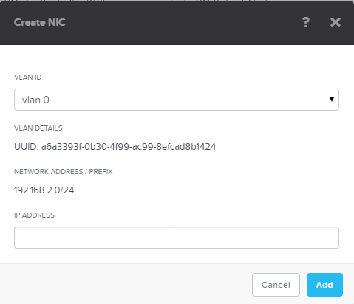

Click the **Add** button to have the network connection added to the VM.

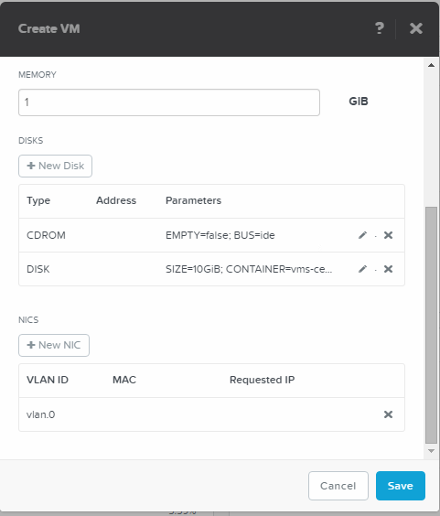

Now click the **Save** button to have the VM be created. The below screen should be seen from the top coming down slowly. This will show you that a VM ub-dsk-ce1 has be created.

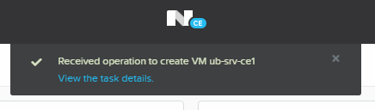

In the tableview we were in we should no see our just created VM.

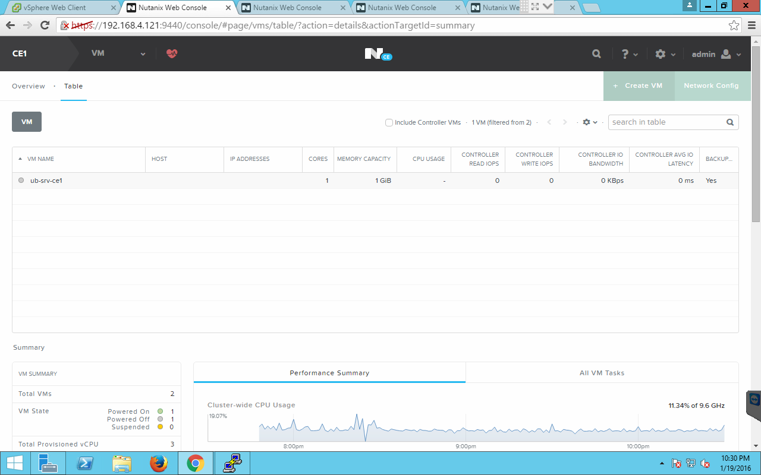

Now let’s start the VM. Hit the **Power On** button **halfway of the page** after having the VM selected!.

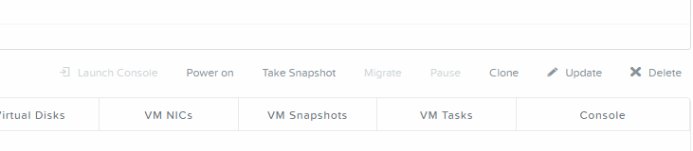



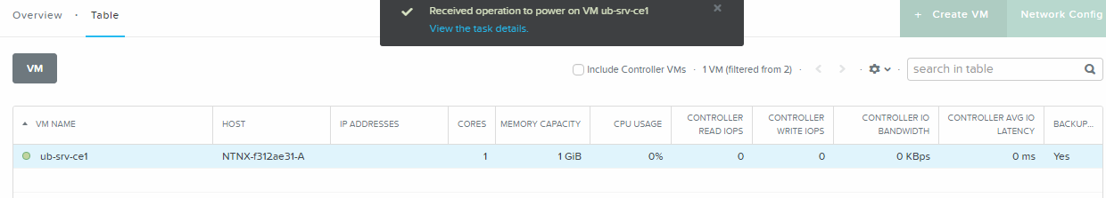

After having the machine given the Power On status, a host will appear in the table view. Not sooner!

Now hit the **Launch Console** button to the left side of the **Power On** button to see the console of the VM.

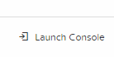

A VNC screen will open top show the console of the VM.

**You don’t have to install it!! Just let the VM Run in the background**

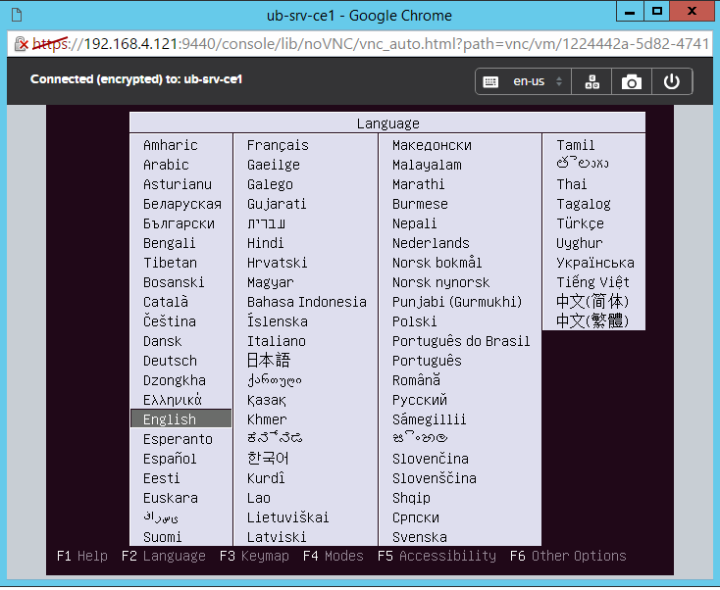

If you want, test all button on the right-hand side of the VNC console to see what they do.

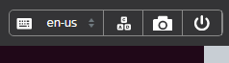

**THIS CONCLUDES THE CREATE VIRTUAL NETWORK AND VM SECTION OF THIS DOCUMENT**

# VM Cloning

Let’s clone a VM using the PRISM interface. Click the **Clone** button kin the PRISM interface.

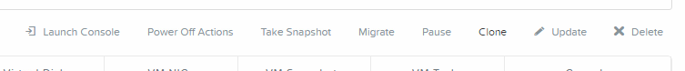

Use the below settings for the clone use for the name the original name and add **-clone** to it. Look at all options you can change!

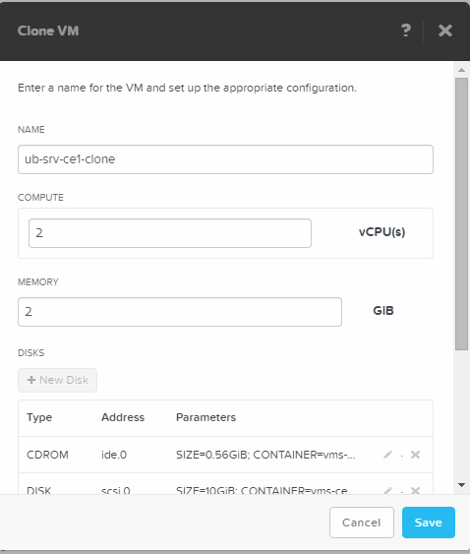

After you have clicked the **Save** button the VM clone should appear in the PRISM UI like below.

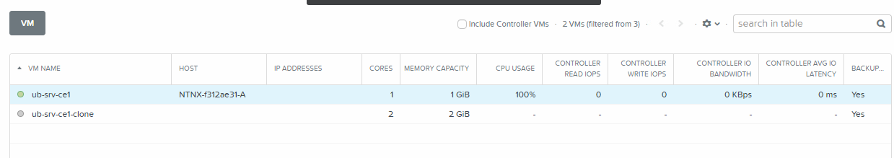



Look at all the options you can monitor after you’ve clicked on one of the VM’s. Information should be there for the first created and powered-on VM.

**THIS CONCLUDES THE VM CLONING SECTION OF THIS DOCUMENT**

# AHV Scripting

AHV is very powerful from a scripting interface the so called acli. The flowing section is providing some basic scripts/commands that can be used in the acli interface.

## VM Creation - Basics

Connect to the CVM using the IP address of your cluster. Use **nutanix** and the **nutanix/4u** as username and password combination.

After the connection is successful type the following command to create a VM with 1G of RAM, 1vCPU and a 10GB disk. For demo purposes the CDROM and the NIC are not used but can be added if wanted. For a full reference to all acli command’s look in the Application Mobile Fabric guide on the support site.

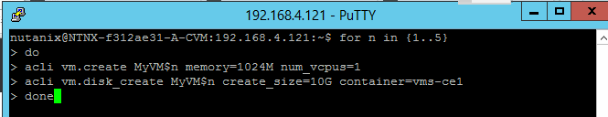

This command should lead in having 5 VM’s named MyVM1 to MyVM5 all with the earlier mentioned parameters. The below screen shows all lines returned by the cluster.

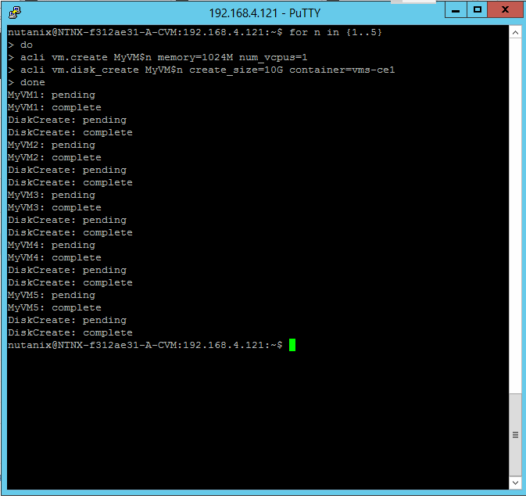

PRISM will show all just 5 newly EXTRA created VM’s

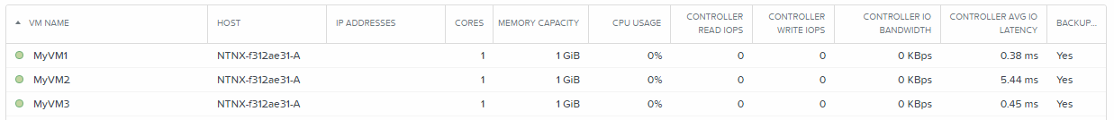

## VM Cloning

Before we can clone machines, we need to get some resources freed-up. So power done the earlier created clone using the UI named ub-srv-cex by using the **acli vm.off** command

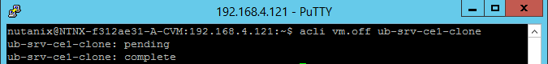

The PRISM should show a gray coloured icon infront of the VM like below.

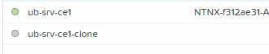

Now let’s delete that VM by using the **acli vm.delete** command and reply **yes** to the asked question if you are sure.

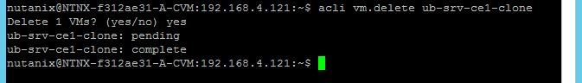

Also delete all earlier created MyVM1 till 5 using the acli vm.delete MyVM[1-4] command like below and reply with yes as well.

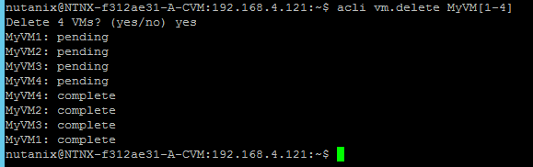

In the PRISM UI the VM’s should be gone except for two.

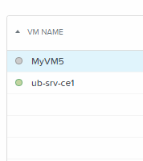

No let’s clone the MyVM5 into 5 new machines called MyVMClone1 to MyVMClone5 by using the **acli vm.clone** command as shown below.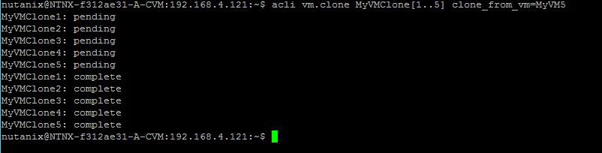

PRISM should show something like this

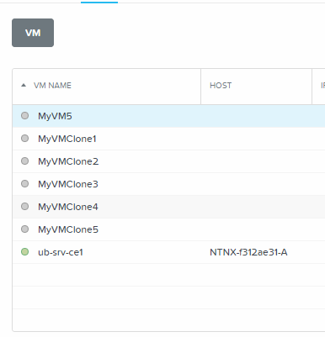

Let’s power on the first three just created VM’s by using **acli vm.on MyVMClone[1-3]** command like below.

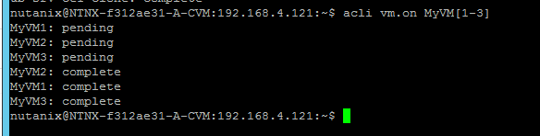

PRISM should show the VM’s with a green ball in front of the VM.

Now let’s delete all earlier created VM by using the **acli vm.delete** command using wildcards like below and answer the question asked with **yes**.

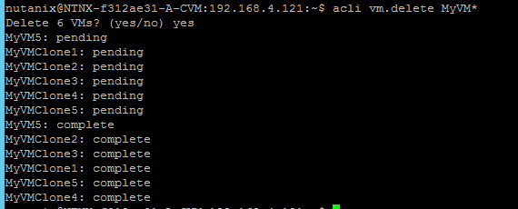

Only one VM should exist in the cluster.

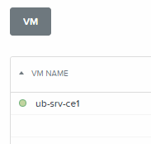

**THIS CONCLUDES THE AHV BASIC Scripting SECTION OF THIS DOCUMENT**